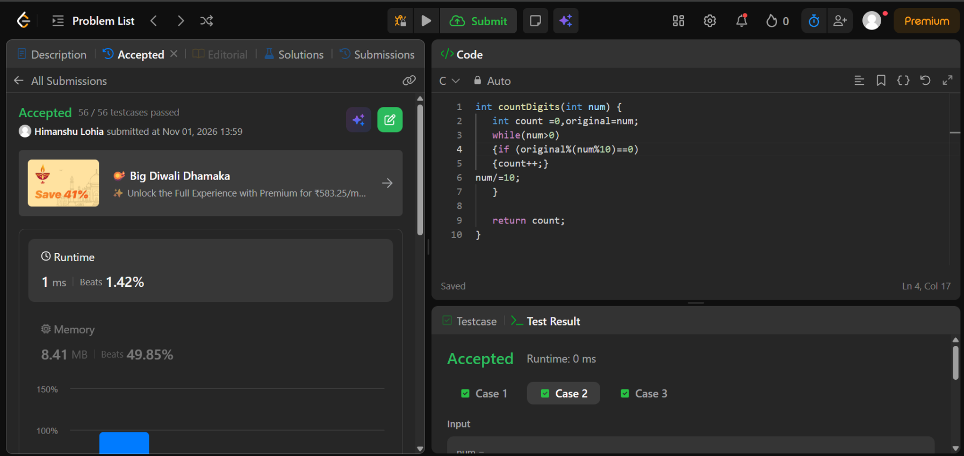
https://leetcode.com/problems/count-the-digits-that-divide-a-number/description/

int countDigits(int num) {
int count =0,original=num;
while(num>0)
{if (original%(num%10)==0)
{count++;}
num/=10;
}

return count;
}

